Browser Extensions

**Clear Cache**

ID: cppjkneekbjaeellbfkmgnhonkkjfpdn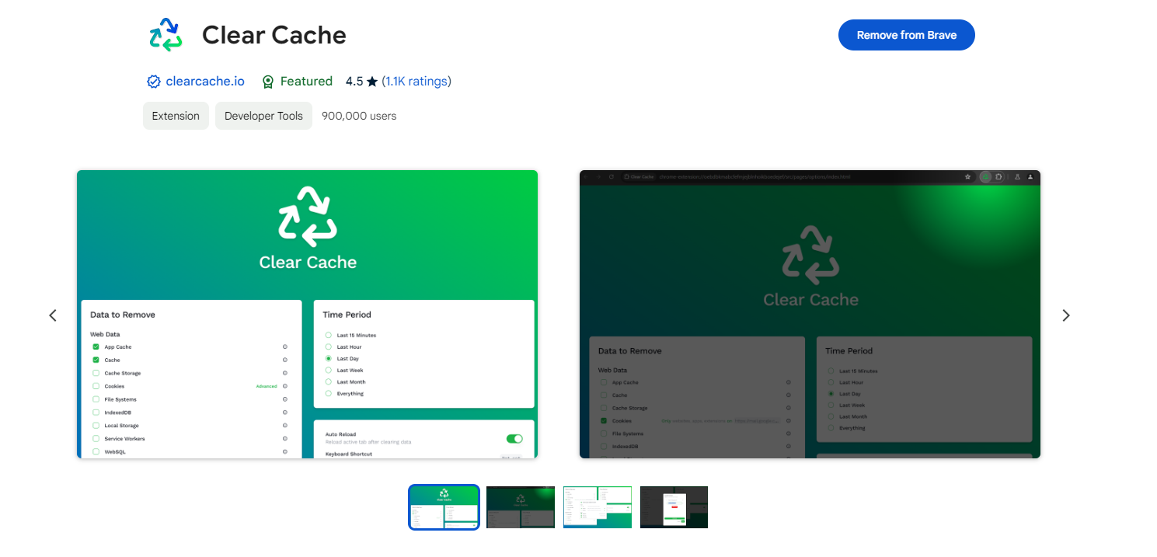

**Dark Reader**

ID: eimadpbcbfnmbkopoojfekhnkhdbieeh

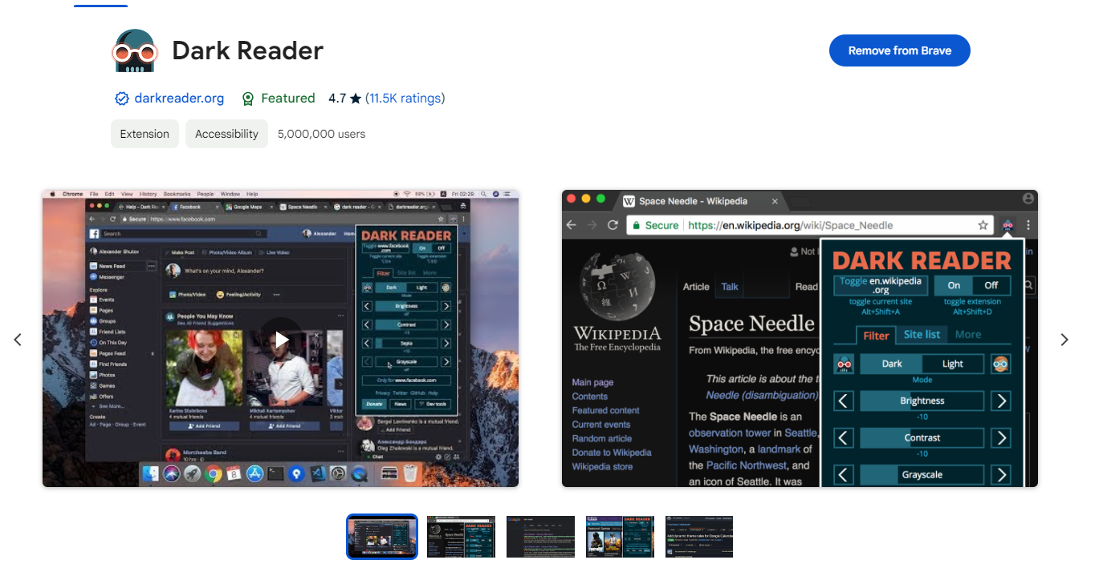

**Fake Filler**

ID: bnjjngeaknajbdcgpfkgnonkmififhfo

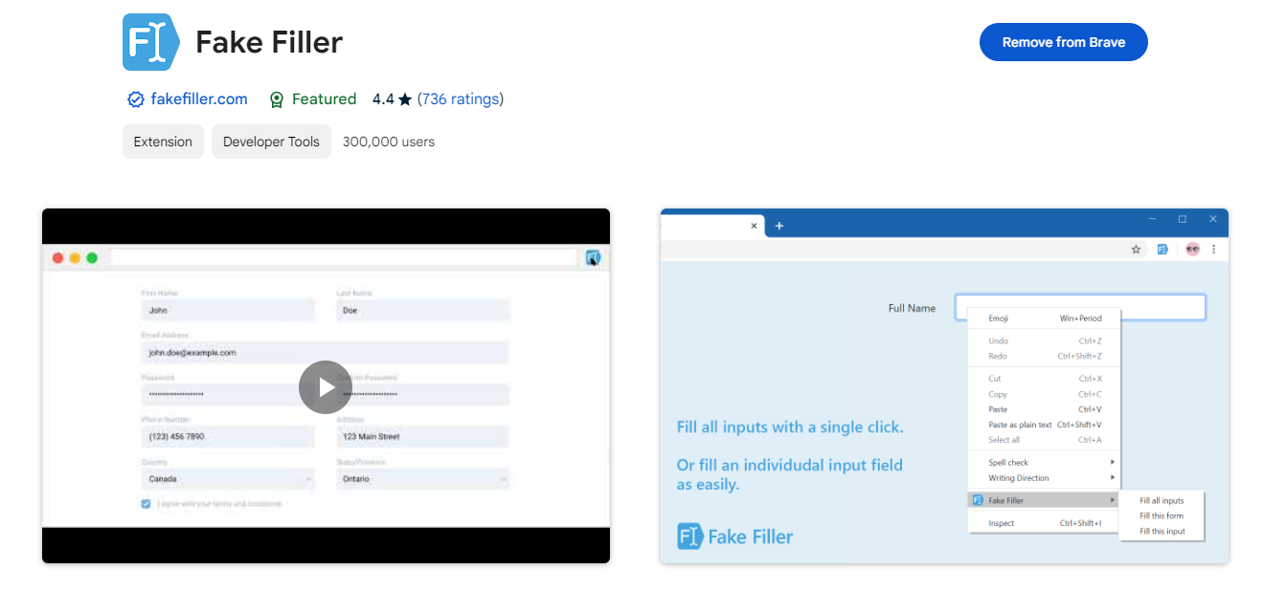

**Free Download Manager**

ID: ahmpjcflkgiildlgicmcieglgoilbfdp

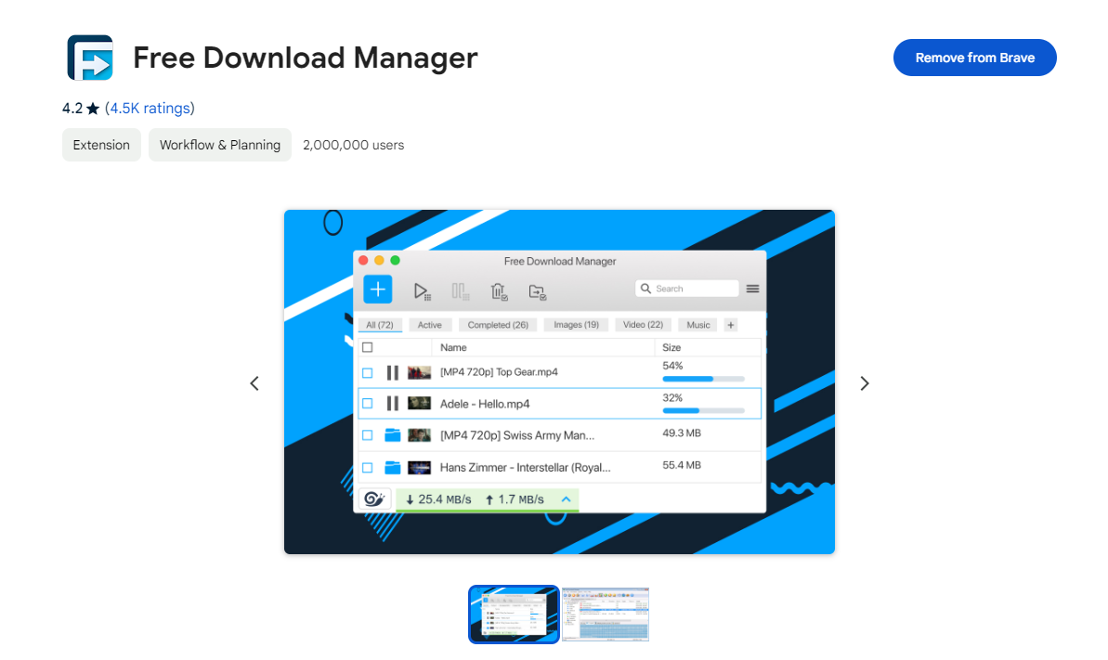

**GitZip for github**

ID: ffabmkklhbepgcgfonabamgnfafbdlkn

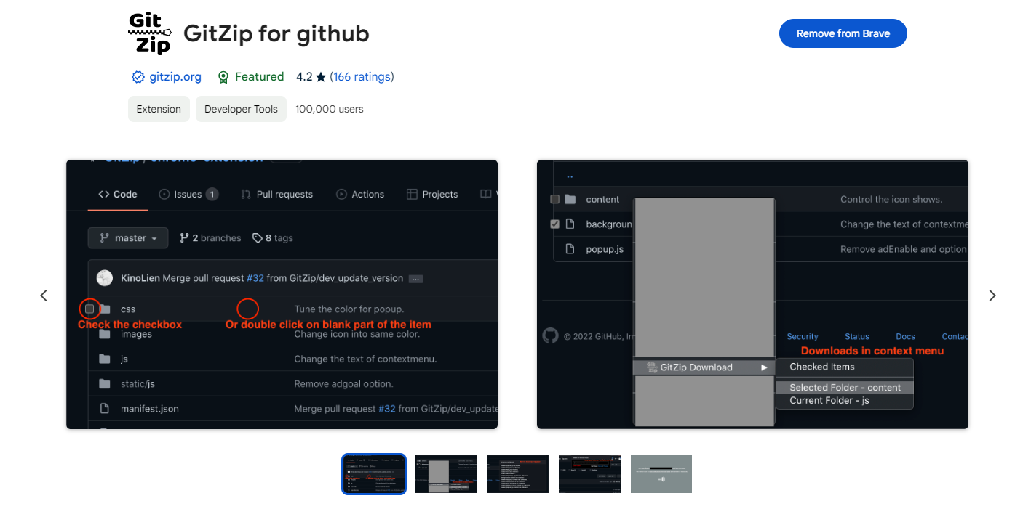

**JSON Formatter**

ID: bcjindcccaagfpapjjmafapmmgkkhgoa

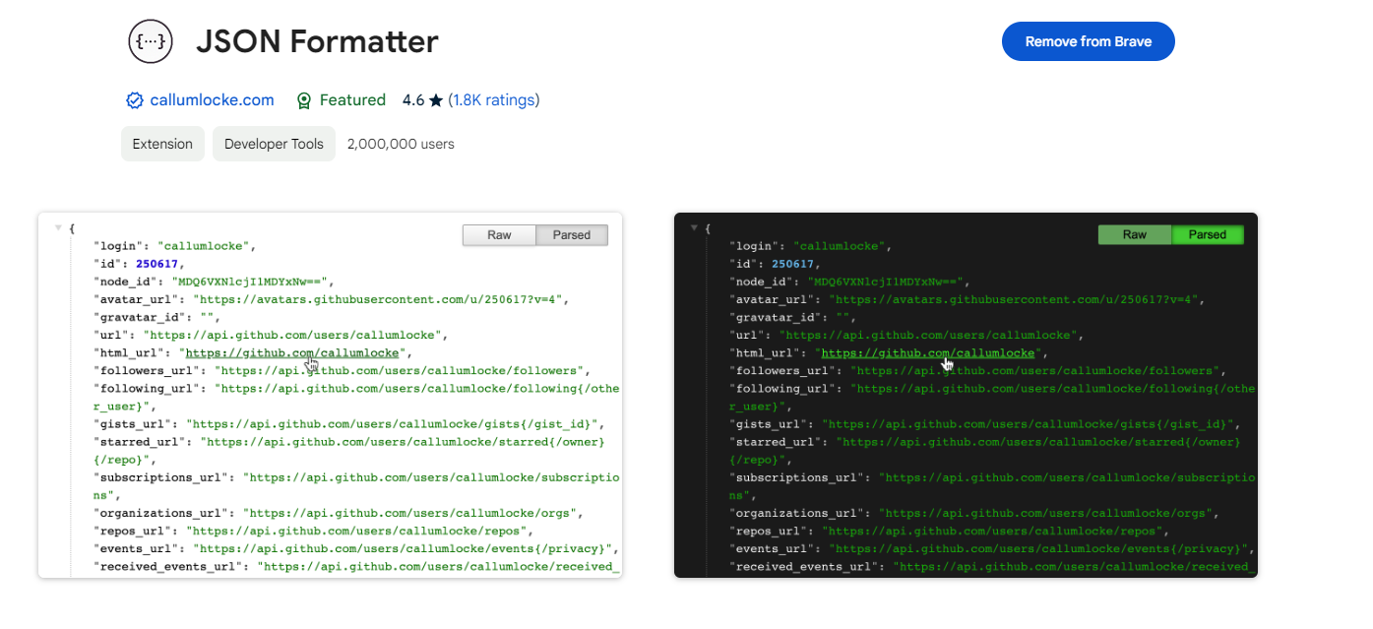

**Material Icons for GitHub**

ID: bggfcpfjbdkhfhfmkjpbhnkhnpjjeomc

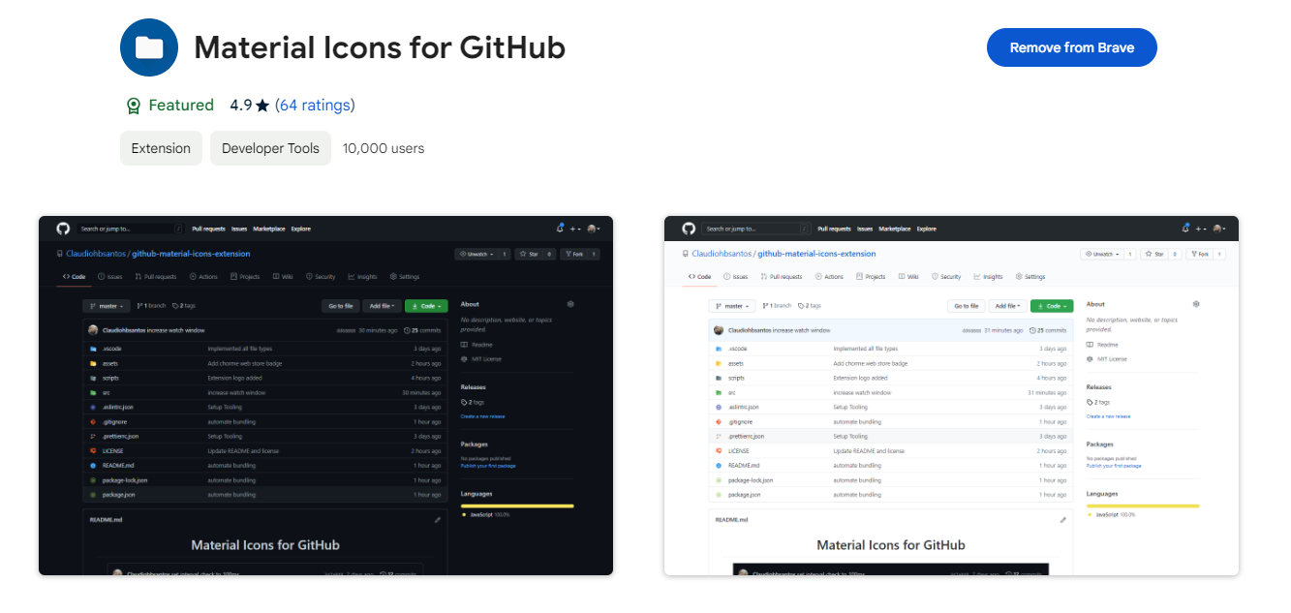

**Picture-in-Picture Extension (by Google)**

ID: hkgfoiooedgoejojocmhlaklaeopbecg

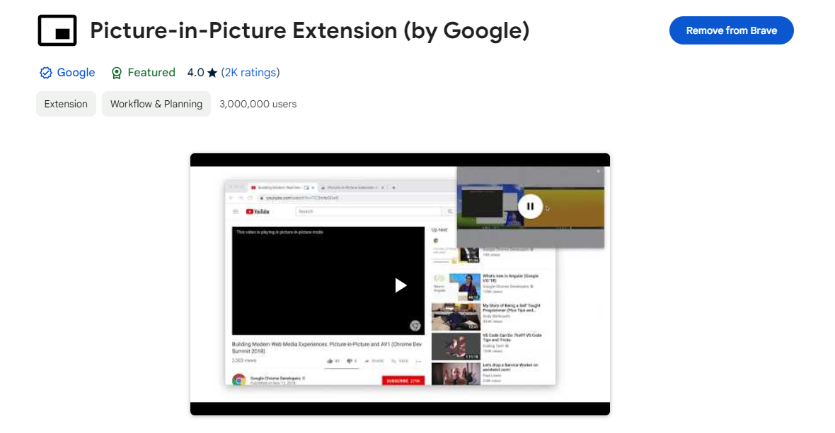

**React Developer Tools**

ID: fmkadmapgofadopljbjfkapdkoienihi

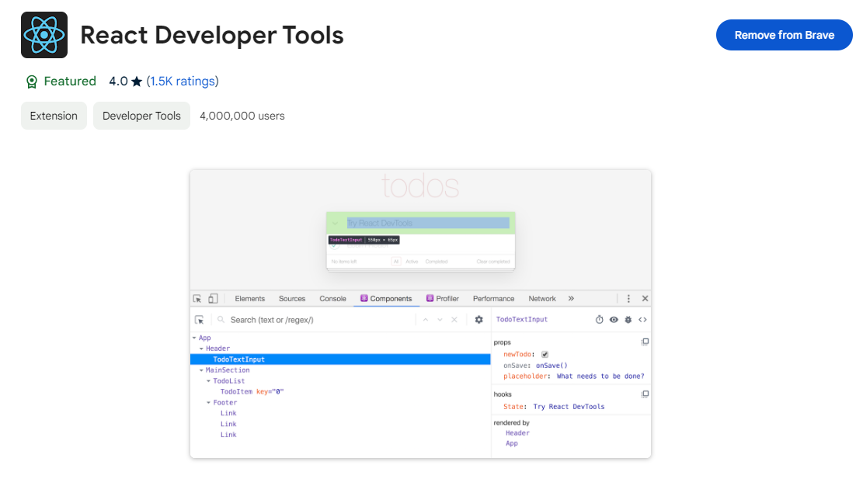

**Redux DevTools**

ID: lmhkpmbekcpmknklioeibfkpmmfibljd

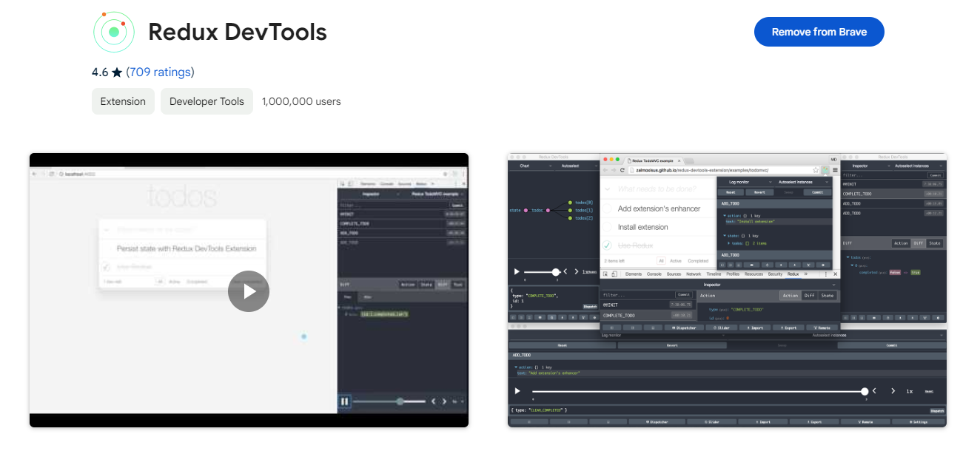

**ScreenGenius - Screenshot & Video Capture Tool**

ID: eclnikmacpcandpbfjkjgnoicmlpkkdj

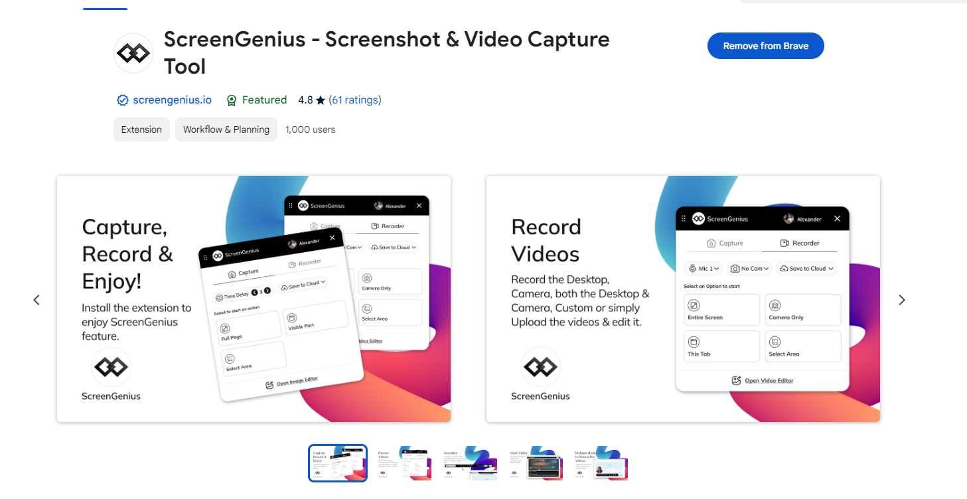

**Wappalyzer - Technology profiler**

ID: gppongmhjkpfnbhagpmjfkannfbllamg



**WhatFont**

ID: jabopobgcpjmedljpbcaablpmlmfcogm

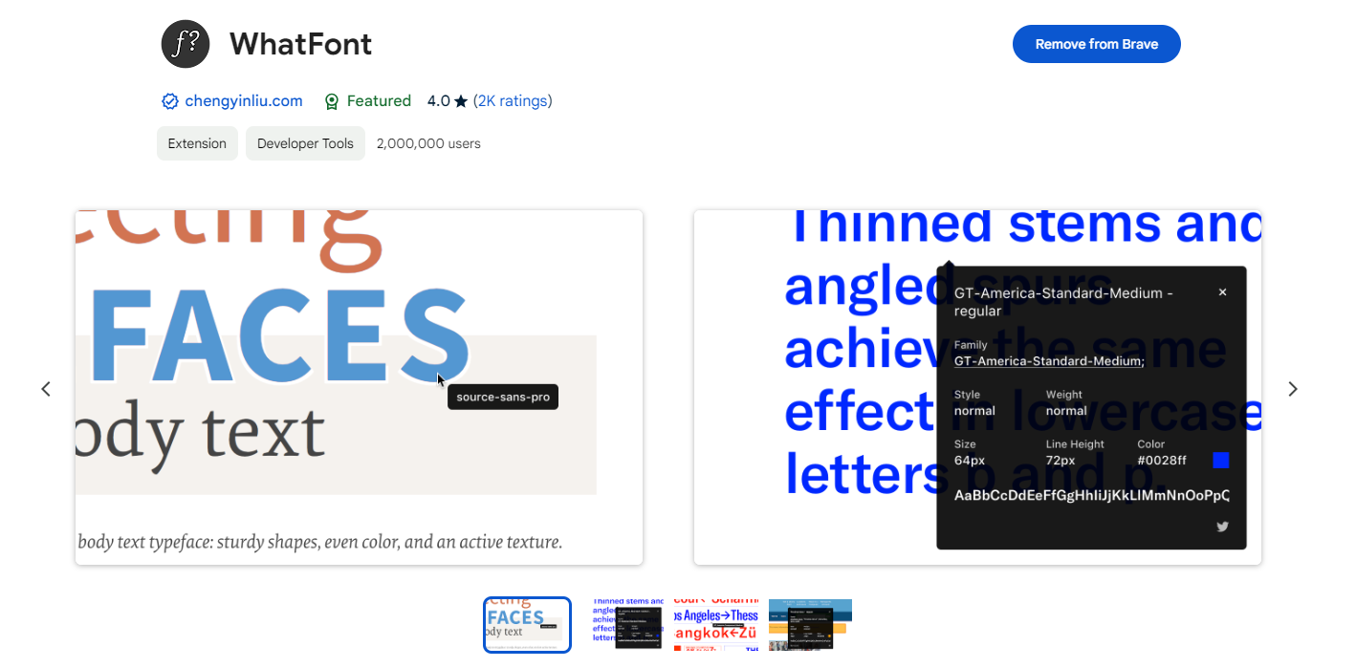

**GitHub Downloader**

ID: jplmabjbdhggnlhndkdfciacklbjcfel

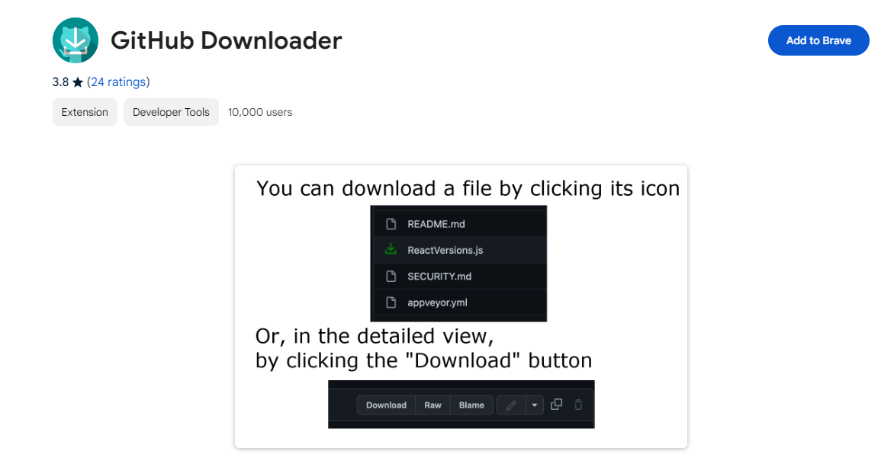

**Copy Text Easily**

ID: fagmaopcbeobbfhkeodicjekiniefdlo

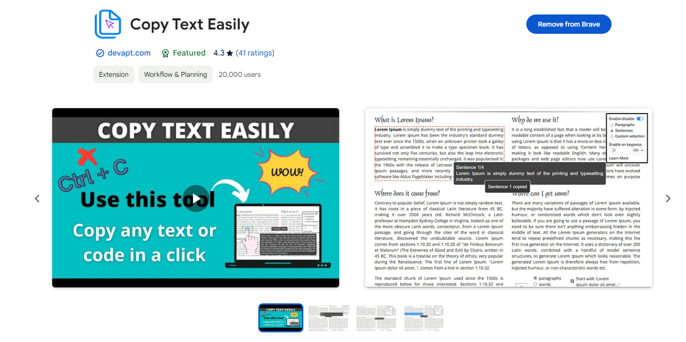

**Allow CORS: Access-Control-Allow-Origin**

ID: lhobafahddgcelffkeicbaginigeejlf

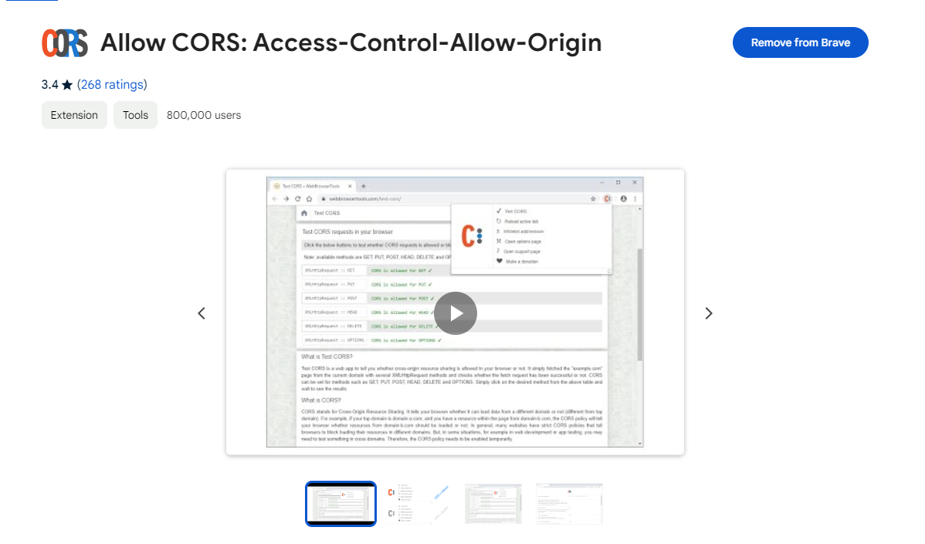

**CSS Scan**

ID: gieabiemggnpnminflinemaickipbebg

